INTERNSHIP TASK SUBMISSION REPORT
Task 1: Responsive Portfolio Website

Submitted by
Hima Agarwal
B.Tech in Computer Science and Engineering
Vellore Institute of Technology, Bhopal
CGPA: 8.84 / 10 | 2024–2028 Batch
Date of Submission: June 12, 2026
Live Website: https://hima-agarwal-11.github.io/portfolio/
GitHub Repository: https://github.com/hima-agarwal-11/portfolio

1. Project Overview
This report documents the design, development, and deployment of a fully responsive personal portfolio website as part of Task 1 of the internship programme. The website, accessible at HA.dev, serves as a digital identity for Hima Agarwal, a Computer Science and Engineering student at Vellore Institute of Technology, Bhopal.

1.1 Purpose and Objectives
The primary goal of this project was to develop a professional, mobile-friendly portfolio website that effectively communicates technical skills, academic background, project experience, and certifications to potential employers and collaborators. The specific objectives were:
- Design and build a multi-section single-page application (SPA) with seamless navigation.
- Implement a fully responsive layout compatible with desktops, tablets, and mobile devices.
- Incorporate modern UI/UX design principles including dark/light theme toggling and animated typing effects.
- Showcase completed projects, technical skills, and professional certifications in an organised, visually engaging manner.
- Deploy the website publicly using GitHub Pages for accessibility and version control.

1.2 Website Sections at a Glance
Section | Description
Home | Hero section with name, animated role titles, bio, CTA buttons, and social links
About | Academic background, education timeline, and relevant coursework
Skills | Tabbed categorisation of technical skills with proficiency bars
Projects | Filterable project gallery with descriptions, tech tags, and GitHub links
Certificates | Grid display of earned certifications with clickable view links
Contact | Contact details and a functional inquiry form

2. Technologies Used
The portfolio was built entirely using front-end web technologies without any external frameworks or libraries, demonstrating core competency in vanilla web development.

Technology | Version / Spec | Purpose
HTML5 | Semantic HTML5 | Document structure, semantic sectioning, accessibility
CSS3 | Custom Properties, Grid, Flexbox | Styling, animations, theming, responsive layouts
JavaScript | ES6+ | Interactivity, typewriter effect, theme toggle, DOM manipulation
CSS Flexbox | CSS3 Standard | Flexible one-dimensional layouts within components
CSS Grid | CSS3 Standard | Two-dimensional page and card layouts
GitHub Pages | Static hosting | Free public deployment and version-controlled hosting
Git | Version Control | Source code management and collaboration

3. Features Implemented

3.1 Navigation Bar with Smooth Scrolling
The site features a fixed navigation bar displaying the brand logo (HA.dev) and links to all six sections. Clicking any nav link triggers smooth scrolling to the corresponding section. The active section is dynamically highlighted via JavaScript IntersectionObserver.

3.2 Hero Section
The landing page hero prominently displays the name, an animated typewriter cycling through professional titles (DSA Enthusiast, Full Stack Developer, etc.), and a personal bio. Call-to-action buttons link to the Projects and Contact sections. Social media links (GitHub, LinkedIn, LeetCode) are displayed below.

3.3 Dark / Light Theme Toggle
A gear/moon icon in the top-right corner allows users to switch between a dark theme (deep navy/black background with cyan-purple accents) and a light theme (soft white/grey background). The selected theme is persisted using localStorage so it survives page refreshes.

3.4 About Section
Provides a detailed personal introduction, a vertical education timeline card layout (VIT Bhopal B.Tech, Class XII, Class X), and a relevant coursework grid covering subjects such as Data Structures & Algorithms, DBMS, OOP, and Web Development Fundamentals.

3.5 Skills Section
Technical skills are organised into five tabbed categories: Languages (C++, Java, Python, C), Core CS, Frontend Web (HTML5, CSS3, JavaScript), Backend & DB, and Tools. Each skill card displays an icon and an animated proficiency progress bar.

3.6 Projects Section
Displays a coding practice summary card (250+ DSA problems on LeetCode) followed by a filterable project gallery. Projects can be filtered by category: All, Web Dev, Software/Java, and AI/ML. Each project card shows the project type badge, title, description, tech-stack tags, and a GitHub code link.

3.7 Certificates Section
A two-row grid of certification cards covering ServiceNow Virtual Internship, Marketing Analysis, Open Source Software, Web Development Workshop, Basics of DSA, Programming in Java, Python Essentials, Cloud Computing, Fundamentals of AI & ML, and MATLAB Onramp. Each card links to the actual certificate.

3.8 Contact Section
Displays contact information (email, phone/WhatsApp, location) alongside a fully structured inquiry form with fields for Full Name, Email Address, Phone Number (optional), Subject, and Message, plus a Send Message button.

3.9 Responsive Design
CSS media queries ensure the layout adapts across viewport widths. The desktop multi-column grid collapses gracefully into single-column stacks on tablets and mobile devices. Font sizes, padding, and image sizes scale proportionally.

4. Implementation Details

4.1 Project File Structure
The project follows a clean separation of concerns with three core files:
- index.html — Contains the complete semantic HTML structure with all sections wrapped in <section> tags bearing meaningful IDs (home, about, skills, projects, certificates, contact).
- style.css — Houses all visual styling using CSS Custom Properties (variables) for the dual-theme colour system, Flexbox/Grid layouts for responsiveness, and keyframe animations for the typewriter effect and progress bars.
- script.js — Manages the typewriter animation loop, theme switching with localStorage persistence, skill tab switching, project category filtering, smooth-scroll behaviour, and the active navigation highlight via IntersectionObserver.

4.2 Responsive Design Approach
The responsive strategy follows a desktop-first methodology with progressive narrowing via CSS media queries. The card grids use CSS Grid with auto-fill and minmax() to naturally reflow without explicit breakpoints where possible. Fixed breakpoints at 1024px (tablet) and 768px (mobile) adjust typography, hide decorative elements, and collapse multi-column layouts.
- Navigation: Collapses into a hamburger menu on mobile viewports.
- Hero Section: Switches from a two-column flex row to a stacked column layout below 768px.
- Skills/Projects/Certificates grids: Transition from 4-column to 2-column to 1-column responsive grids.

4.3 Theme System
CSS Custom Properties defined on the :root element manage the full colour palette. The JavaScript theme toggle switches a data-theme attribute on the <html> element, and CSS attribute selectors ([data-theme='light']) override the root variables, instantly re-theming the entire site without any JavaScript style injection.

4.4 GitHub Pages Deployment
The deployment process followed these steps:
- Initialised a local Git repository and committed all project files.
- Created a public GitHub repository named 'portfolio' under the account hima-agarwal-11.
- Pushed the local repository to GitHub via: git remote add origin <url> && git push -u origin main.
- Enabled GitHub Pages in repository Settings > Pages, selecting the main branch as the source.
- GitHub automatically built and published the site at https://hima-agarwal-11.github.io/portfolio/.

5. Screenshots
The following screenshots document each major section of the completed portfolio website.

5.1 Home Page – Dark Theme
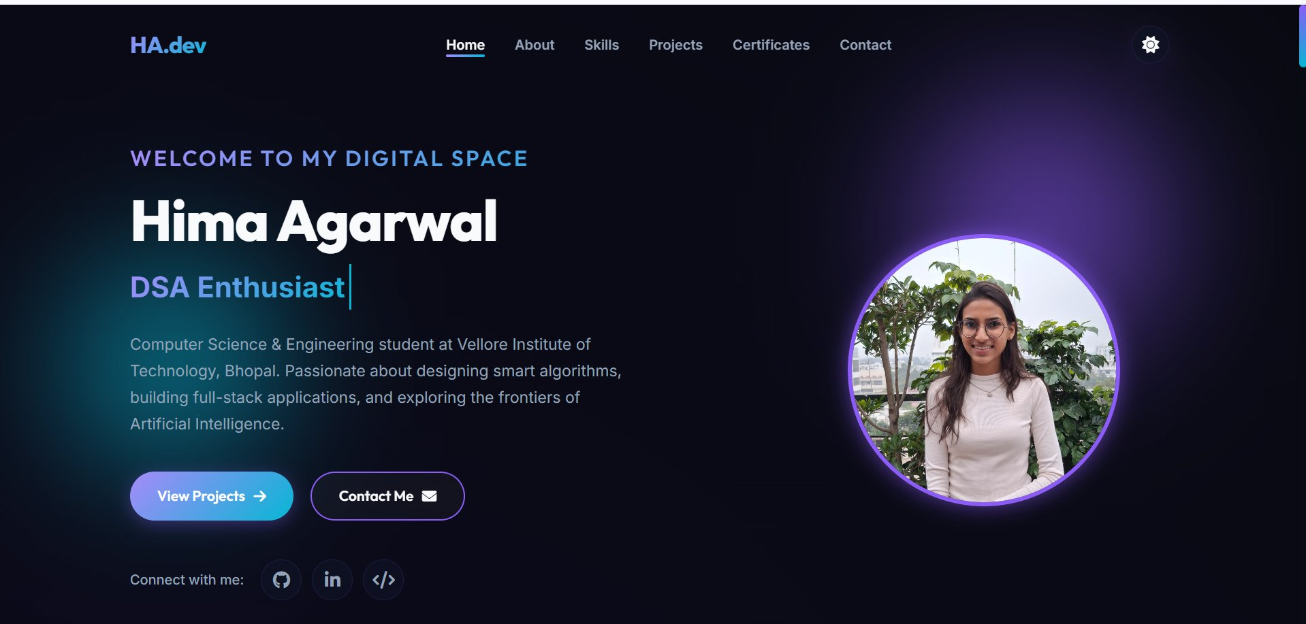
Figure 1: Home page in dark theme showing hero section with name, typewriter title, bio, CTA buttons, and social links.

5.2 Home Page – Light Theme
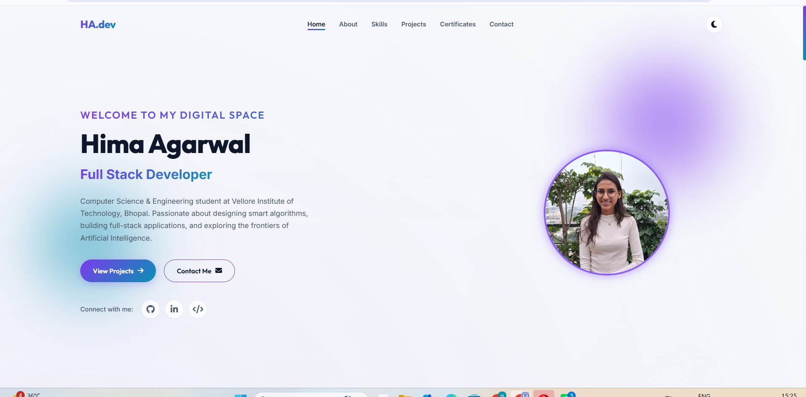
Figure 2: Home page in light theme, demonstrating the dual-theme system with the same content on a bright background.

5.3 About Section
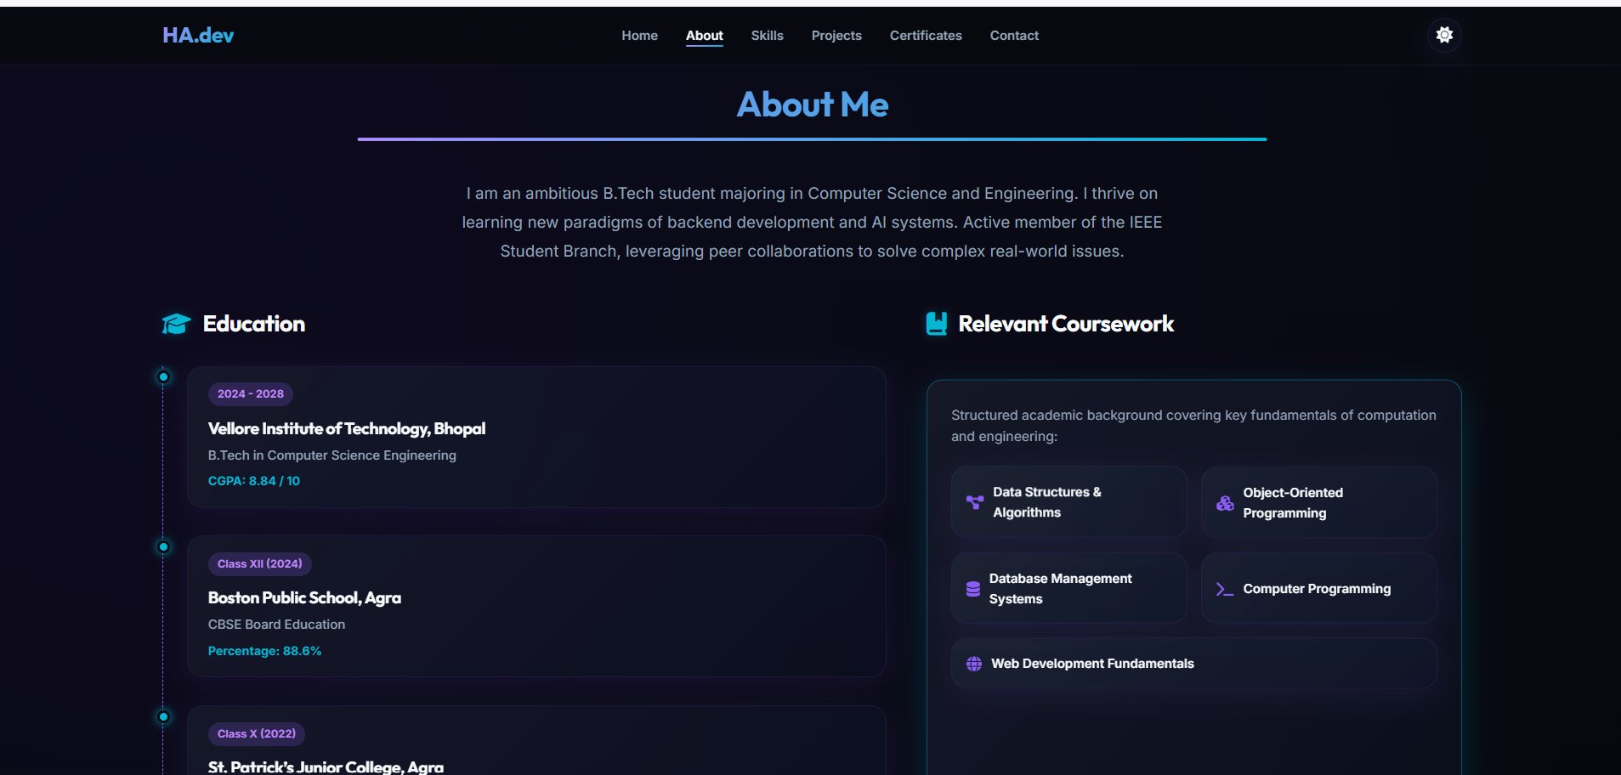
Figure 3: About Me section displaying the personal bio, vertical education timeline (VIT Bhopal, Class XII, Class X), and relevant coursework grid.

5.4 Technical Skills – Languages Tab
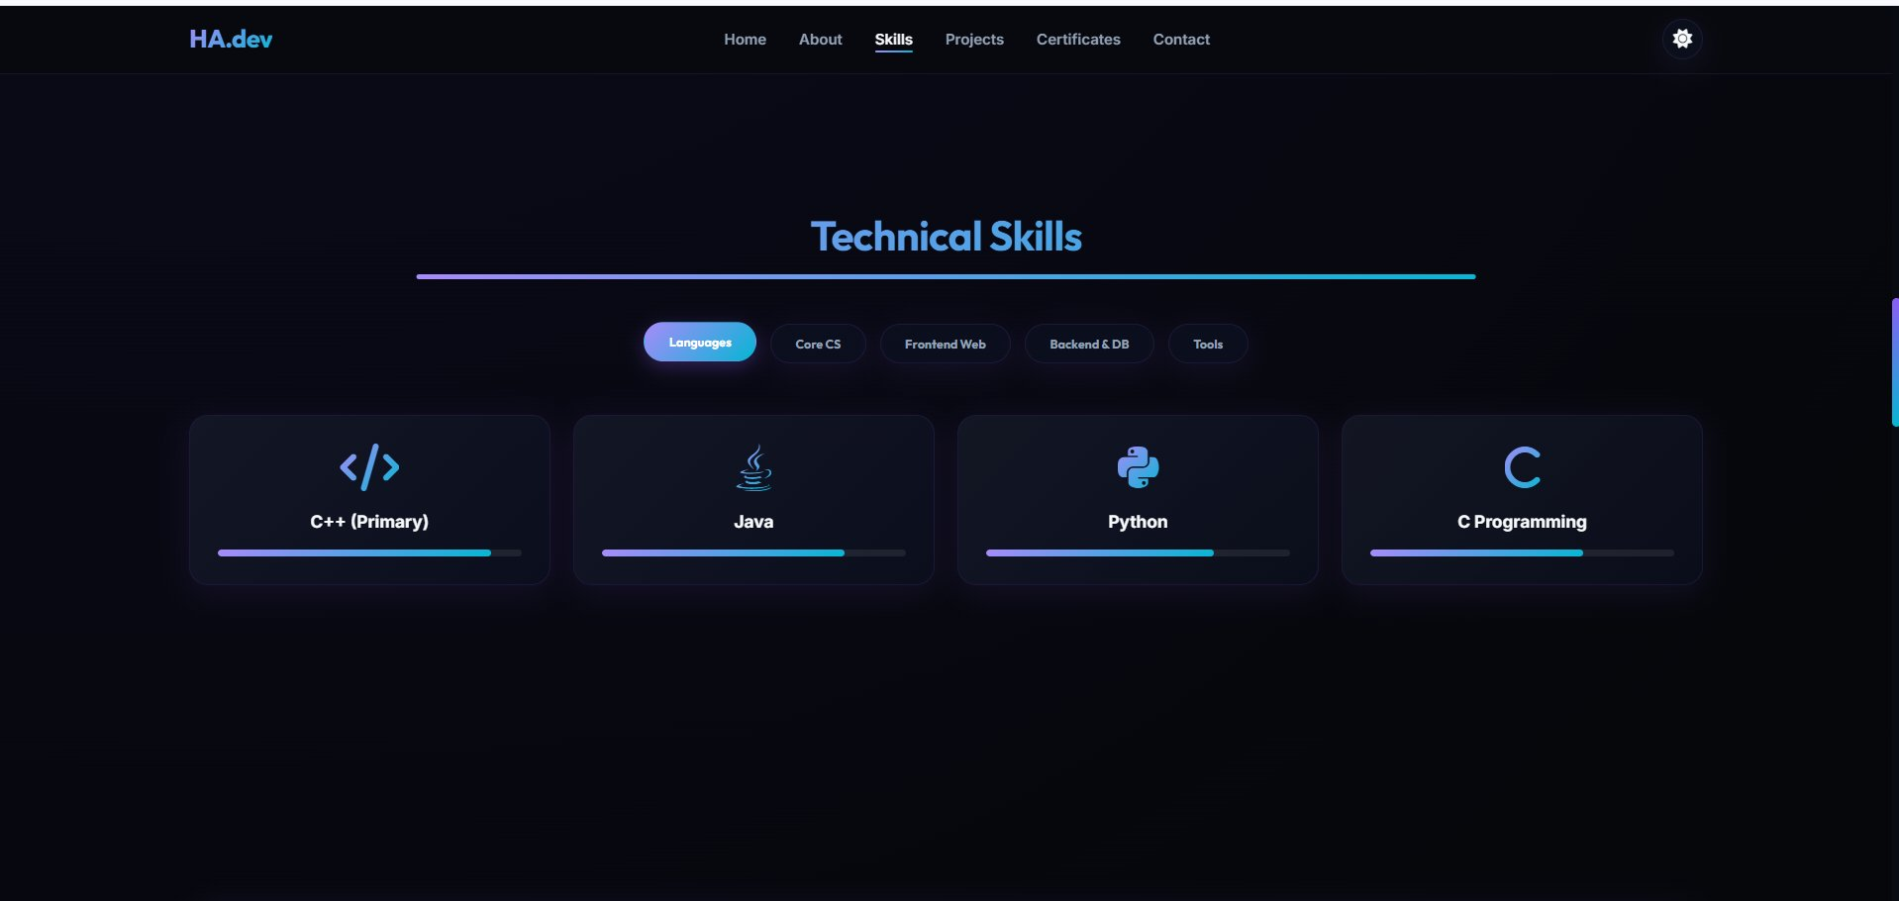
Figure 4: Skills section with Languages tab active, showing C++ (Primary), Java, Python, and C Programming skill cards with proficiency bars.

5.5 Technical Skills – Frontend Web Tab
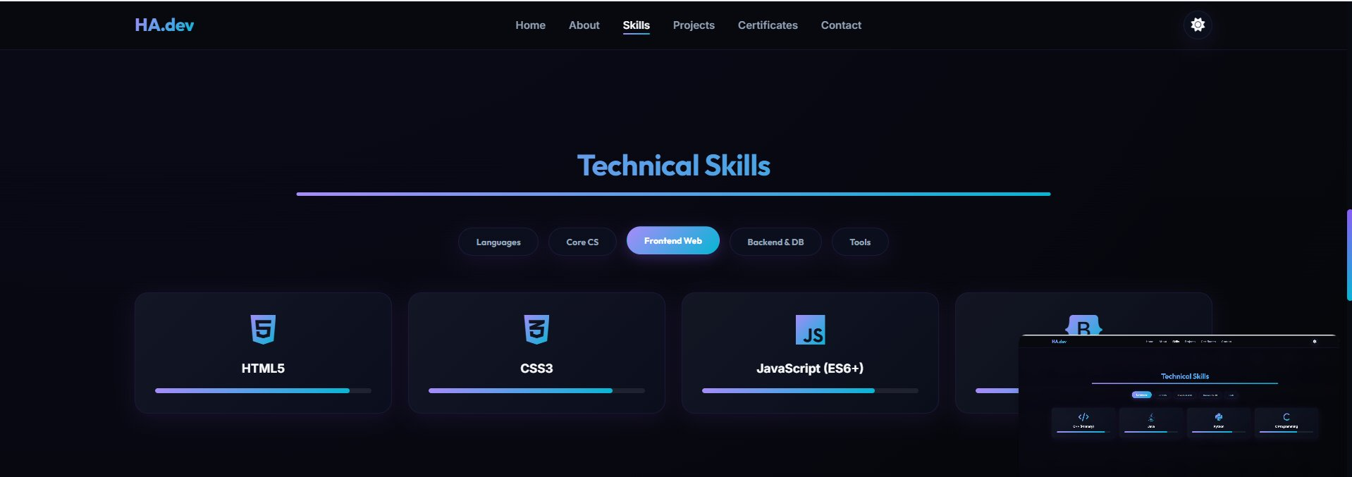
Figure 5: Skills section with Frontend Web tab active, displaying HTML5, CSS3, and JavaScript (ES6+) skill cards.

5.6 Coding Practice & Projects Header
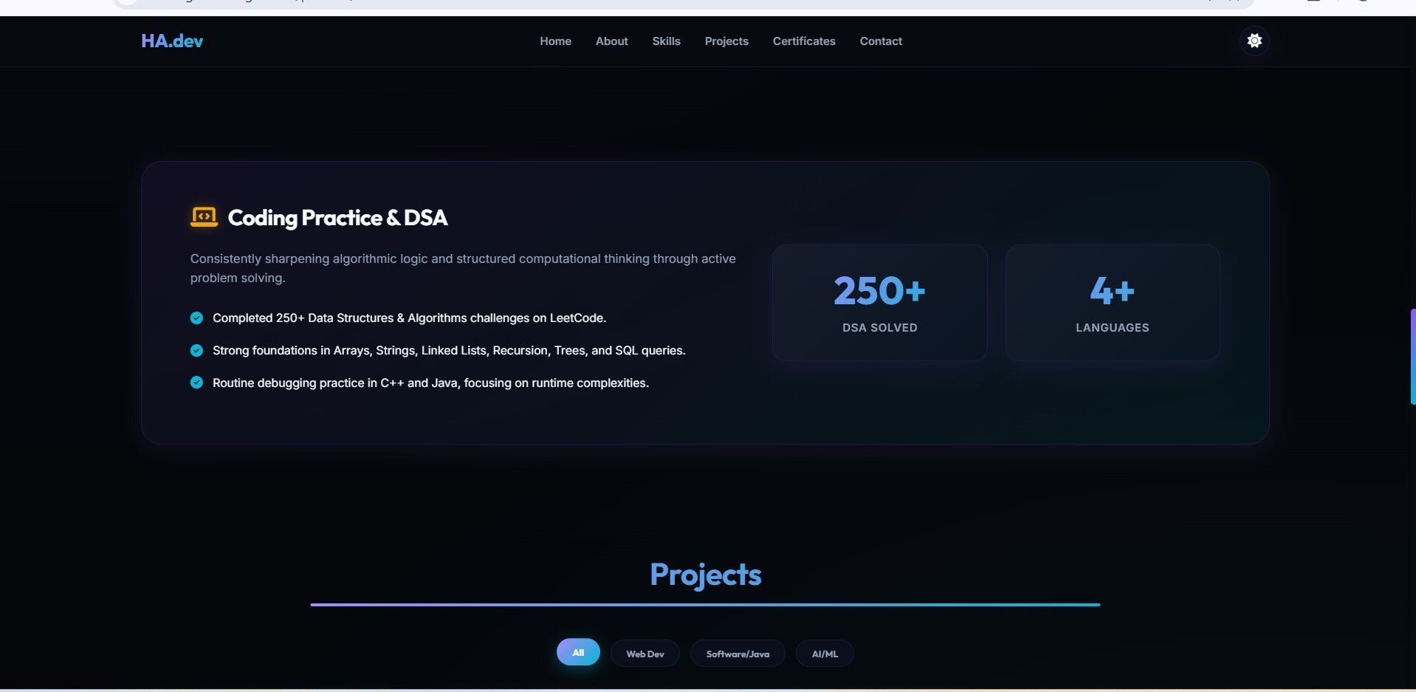
Figure 6: Coding Practice & DSA summary card (250+ LeetCode problems, 4+ languages) and the start of the filterable Projects section.

5.7 Projects Gallery
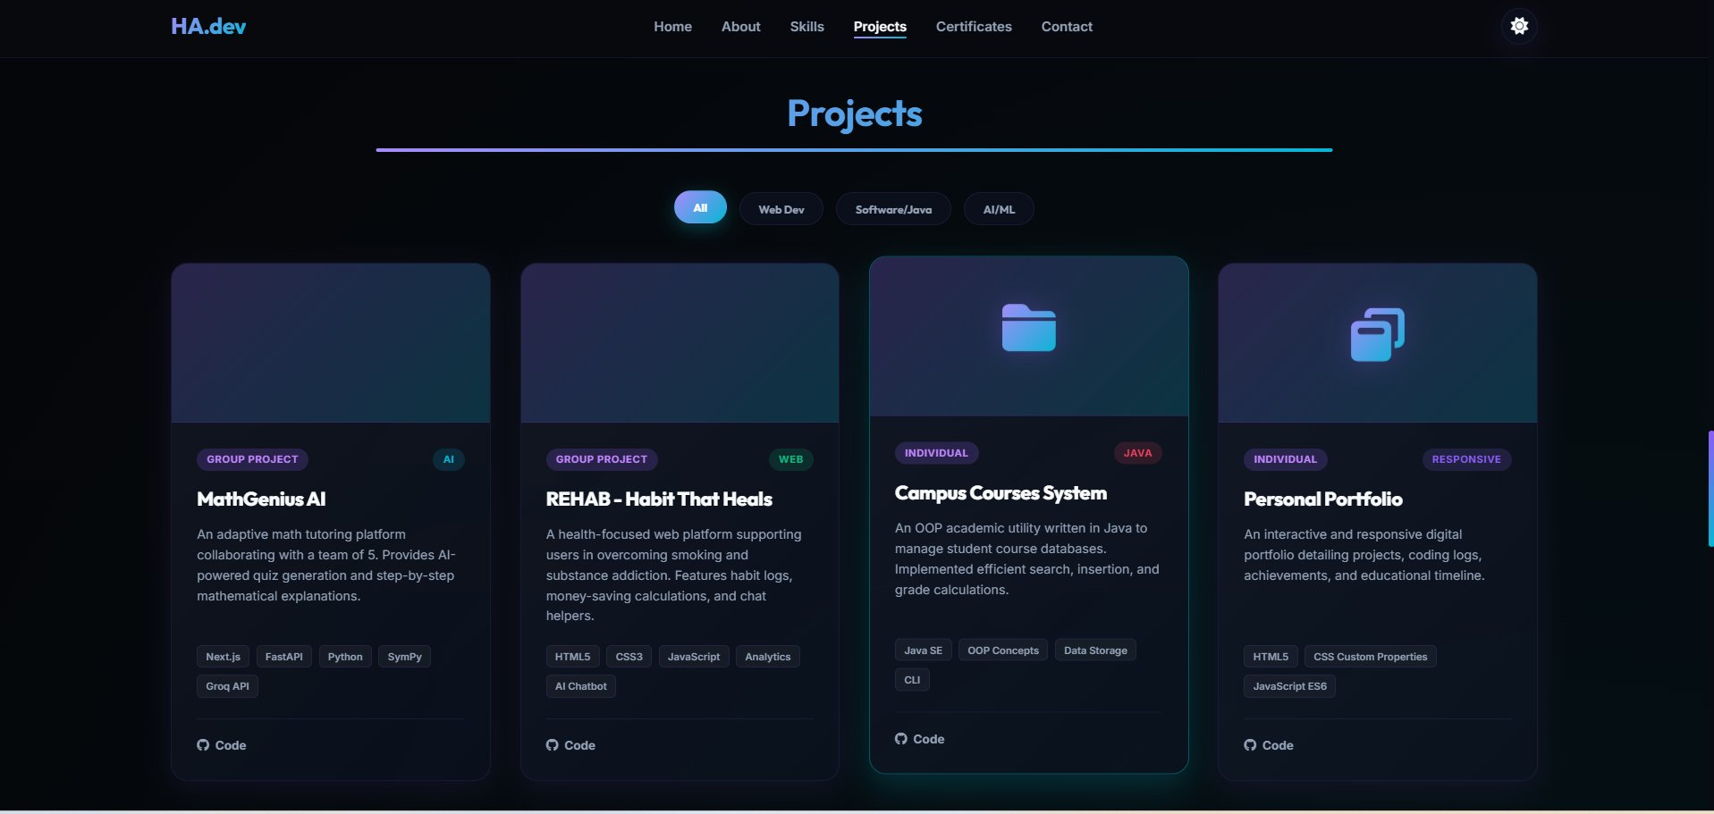
Figure 7: Projects grid showing MathGenius AI, REHAB – Habit That Heals, Campus Courses System, and Personal Portfolio with tech-stack tags and GitHub links.

5.8 Certifications Section
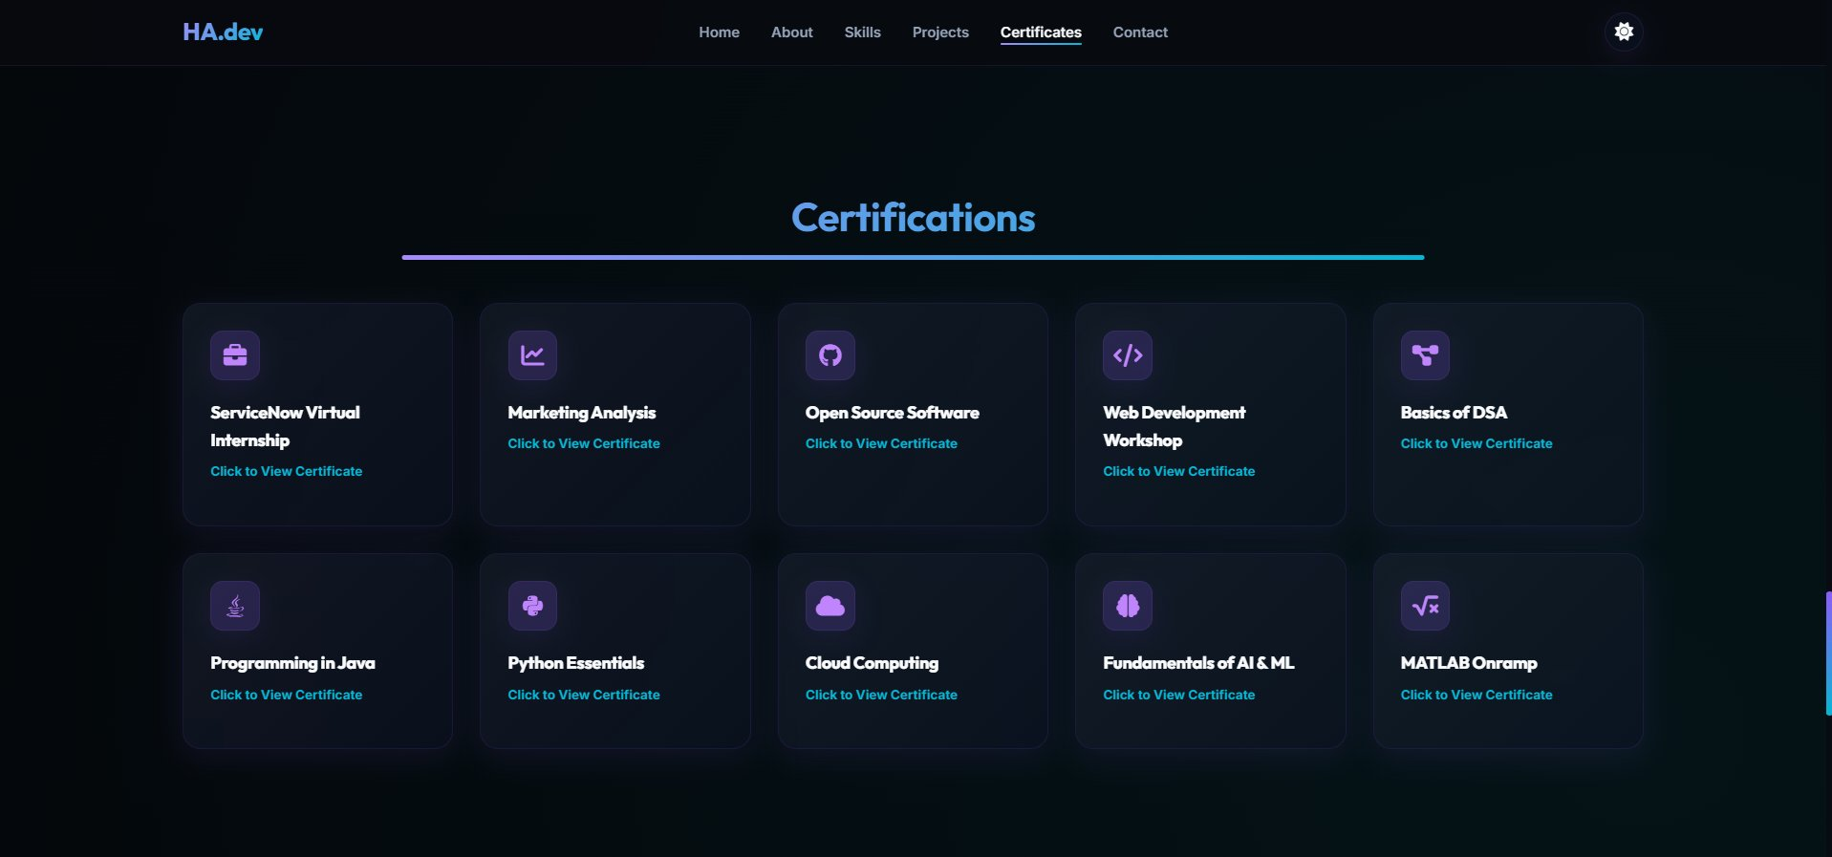
Figure 8: Certifications page displaying 10 certificates in a two-row grid layout including ServiceNow, AI & ML, Cloud Computing, and Python Essentials.

5.9 Contact Section
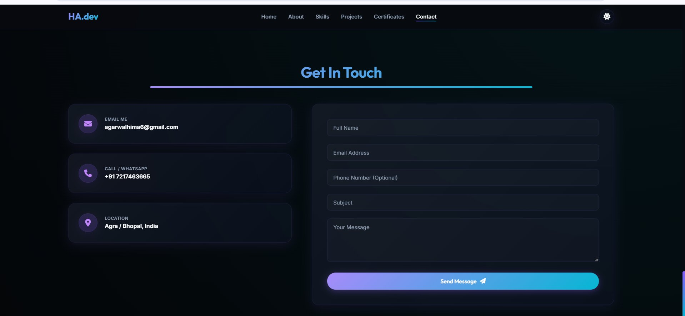
Figure 9: Contact section with contact information cards (email, phone/WhatsApp, location) and a structured inquiry form with Send Message button.

6. Source Code Highlights

6.1 Typewriter Animation (JavaScript)
An array of role strings is cycled through using a setInterval-based character appender. Once a string is fully typed, a short pause triggers a character-by-character deletion before the next string begins. This creates the continuous animated typing effect visible on the hero section.

6.2 Theme Toggle (JavaScript + CSS)
The theme toggle function reads the current data-theme attribute on document.documentElement, flips it between 'dark' and 'light', and immediately writes the new value to localStorage. On page load, an initialisation script reads localStorage before the DOM renders, preventing any flash of the default theme.

6.3 CSS Custom Properties for Theming
Both themes are defined using CSS Custom Properties on :root and [data-theme='light'] selectors. Key variables include --bg-primary, --bg-secondary, --text-primary, --accent-primary (cyan), and --accent-secondary (purple). All component styles reference only these variables, ensuring a single attribute change re-themes the entire interface.

6.4 Project Filter (JavaScript)
Each project card is tagged with a data-category attribute. The filter buttons dispatch click events that compare the selected category string against each card's dataset value, toggling a CSS class to show or hide cards. The 'All' filter disables filtering entirely and reveals all cards simultaneously.

6.5 Intersection Observer for Active Nav Highlighting
An IntersectionObserver monitors each section element with a threshold of 0.3. When a section enters the viewport, its corresponding navigation link receives an 'active' class, and the class is removed from all other links. This gives real-time visual feedback about the user's scroll position without any scroll-event listeners.

6.6 Responsive Grid (CSS)
The skill and project card grids use the declaration: grid-template-columns: repeat(auto-fill, minmax(220px, 1fr)). This intrinsically responsive pattern creates as many columns as the viewport allows without explicit breakpoint logic, naturally collapsing to fewer columns on smaller screens.

7. Repository and Live Website

Resource | Link
GitHub Repository | https://github.com/hima-agarwal-11/portfolio
Live Website | https://hima-agarwal-11.github.io/portfolio/
Hosting Platform | GitHub Pages (free static hosting)

8. Learning Outcomes

8.1 Skills Acquired
- Gained hands-on experience with semantic HTML5 structuring and accessibility best practices.
- Deepened understanding of CSS Custom Properties as a maintainable theming mechanism.
- Developed proficiency in CSS Flexbox and Grid for complex, responsive multi-column layouts.
- Learned to implement JavaScript animations (typewriter effect) without third-party libraries.
- Understood the IntersectionObserver API for performant scroll-based UI updates.
- Gained practical experience with Git version control and GitHub Pages deployment workflow.

8.2 Challenges Faced and Solutions
Challenge | Solution
Achieving consistent cross-device responsiveness | Adopted a grid-first layout using minmax() and tested on multiple viewport widths via browser DevTools.
Preventing theme flash on page load | Injected a tiny synchronous localStorage-read script in the <head> to set data-theme before CSS renders.
Smooth typewriter loop without jitter | Used nested setTimeout calls instead of setInterval for precise, sequential character timing.
Maintaining consistent dark/light colour contrast ratios | Used CSS Custom Properties globally and validated colour contrast with browser accessibility tools.
Project card filter animation appearing abrupt | Added CSS opacity and transform transitions triggered by toggling a .hidden class for smooth appear/disappear effects.

9. Conclusion
The Responsive Portfolio Website (Task 1) has been successfully designed, developed, and deployed as a fully functional, publicly accessible web application. The project meets all stated requirements: it uses HTML5, CSS3, and JavaScript without external frameworks; incorporates a responsive Flexbox/Grid layout; features a navigation bar with smooth scrolling; and is live-hosted via GitHub Pages.

Beyond the technical requirements, the website demonstrates several advanced features including a CSS Custom Property-driven dual-theme system, a JavaScript typewriter animation, an IntersectionObserver-powered active-nav tracker, and a filterable project gallery. These additions reflect a commitment to delivering a polished, production-quality user experience rather than a minimal specification-compliant deliverable.

The development process reinforced foundational web development skills and introduced real-world challenges around cross-device compatibility, performance, and deployment. All challenges were addressed using native browser APIs and CSS capabilities, resulting in a zero-dependency codebase that loads quickly and functions reliably across modern browsers.

The portfolio is live at https://hima-agarwal-11.github.io/portfolio/ and the source code is publicly available at https://github.com/hima-agarwal-11/portfolio. This project forms a solid foundation for subsequent internship tasks and serves as an ongoing professional presence on the web.

Hima Agarwal
B.Tech Computer Science and Engineering — VIT Bhopal
agarwalhima6@gmail.com | +91 7217463665 | Agra / Bhopal, India
GitHub: github.com/hima-agarwal-11

